
ASSIGNMENT COVERSHEET FOR INDIVIDUAL WORK
Faculty of Design and Creative Technologies
First Name |  |  | Family Name |  | Student ID No
Paper Name |  |  | Paper Code: |  | Assignment Due Date
Lecturer: |  |  | Tutorial Day |  | Date Submitted
Tutor: |  |  | Tutorial Time |  | No.Words/Pages
In order to ensure fair and honest assessment results for all students, it is a requirement that the work that you hand in for assessment is your own work. If you are uncertain about any of these matters then please discuss them with your lecturer.

Plagiarism and Dishonesty are methods of cheating for the purposes of General Academic Regulations (GAR)
http://www.aut.ac.nz/calendar
Assignments will not be accepted if this section is not completed and signed.

Please read the following and tick to indicate your understanding:

- I understand it is my responsibility to keep a copy of my assignment. ☐ Yes ☐ No

- I have signed and read the Student's Statement below. ☐ Yes ☐ No

- I understand that a software programme (Turnitin) that detects plagiarism ☐ Yes ☐ No
and copying may be used on my assignment.
Student's Statement:

This assessment is entirely my own work and has not been submitted in any other course of study. I have submitted a copy of this assessment to Turnitin, if required.
In this assessment I have acknowledged, to the best of my ability:

- The source of direct quotes from the work of others.
- The ideas of others (includes work from private or professional services, past assessments, other students, books, journals, cut/paste from internet sites and/or other materials)
- The source of diagrams or visual images.

Student's Signature: Date:

The information on this form is collected for the primary purpose of submitting your assignment for assessment. Other purposes of collection include receiving your acknowledgement of plagiarism polices and attending to administrative matters. If you choose not to complete all questions on this form, it may not be possible for the Faculty of Design and Creative Technologies to accept your
assignment.

Author: Academic Office, Faculty of Design and Creative Technologies Page 1 of 1 Subject: Individual Assignment Cover sheet
Version 2.0 Issue Date: 01/01/2009 Last Updated: 20/07/2009

Auckland University of Technology



School of Engineering, Computer and Mathematical Science

ENEL700 Communication Engineering

Formal Lab Report (or Assignment )

Submitted by: Peter Smith
Student ID: 128434305

2 September 2024

Table of Contents

1 Introduction (Use style Heading 1) 3
1.1 Background (Use style Heading 2) 3
1.2 Introduction to Microcontroller 3
2 Objectives (Use style Heading 1) 4
3 Methodologies 4
3.1 Design of Flowchart 4
3.1.1 Flowchart Components 4
4 Results 5
4.1 Simulation Results 5
4.2 Experimental Results 5
4.3 Comparison of Results 5
5 Discussions 5
6 Conclusion 5
7 References 5
8 Appendix 5

Introduction (Use style Heading 1)
This template serves as an example for report writing and assignment submission in digital format [1].

Background (Use style Heading 2)

For equations, please numerate them according their appearance in the report.
$A=πr^{2}$ (1)
${\left(x+a\right)}^{n}=\sum_{k=0}^{n}{\left({n \atop k}\right)x^{k}a^{n-k}}$ (2)

Introduction to Microcontroller

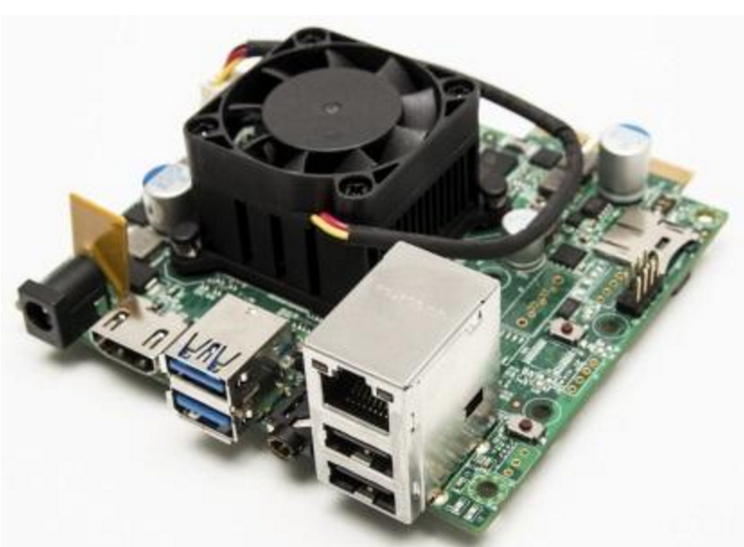
Figure 1. A sample of Embedded Digital System (using Figure Caption)

Objectives (Use style Heading 1)

Table 1. List of Available Microcontrollers (using Table Caption)
S/N | Brand | Model | I/O Type
1 | Amtel | AT90USB1287
2 | TI
3 | Microchip

Methodologies

Design of Flowchart

Flowchart Components

Results

Simulation Results

Experimental Results

Comparison of Results

Discussions

Conclusion

References
[1] I. Grant, How to speak well in public and in private!, 302.2GRA ed.: Random House New Zealand, 2007.

Appendix

